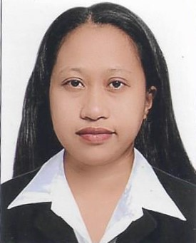
SHIELA CELESTIAL PASTORAL
Zone 2 Santiago Old, Nabua Camarines Sur
Contact #:09102221236/09617213880
lifemhine01@gmail.com

CAREER OBJECTIVES

- To gain any position in your organization that will fit my qualification and will require my best effort to do my responsibilities properly.
- To obtain an entry level position in an establishment which utilizes my interests and abilities where my qualities as a fast learner and the ability to take new challenges can be used and have an opportunity for advancement.

WORK EXPERIENCES

Laboratory Aide
Rural Health Unit 1
Nabua Camarines Sur
Contact #: 054-2883506
Jan. 2020-Present

Subject Teacher
Victor Bernal High School
San Vicente Nabua, Camarines Sur

Laboratory Aide
Rural Health Unit 1
Nabua Camarines Sur
Contact #: 054-2883506
April 2016-Dec. 2017

Receptionist
Mitzuki General Trading LLC
White Crown Building, Dubai UAE
Contact #: +97142353255
Visa: January - March 2016

Caregiver/Household worker
Al Hazmi Villa, 156 Al Ramaqia, Sharjah UAE
September 23, 2013 – December 30, 2015

Shop Attendant/Cashier
C&P Typing and Photocopying Services
Mangga Rd. Signal Village Taguig City Philippines
Contact #: 0063-2-7755455/0063-2-8384554
2010-2011

CAREER STRENGTH

Hardworking, Fast Learner
Flexible and willing to be trained
Trustworthy
Amenable to shifting schedules
Computer literate
Good Communication skills (Both oral and written)
Can speak Tagalog, English, and Arabic

CERTIFICATE/LICENSES

Licensed Professional Teacher
Lic. No. 1754342

Registered Nurse
Lic No. 0938561

EDUCATIONAL BACKGROUND

College : Bachelor of Science in Nursing
University of Saint Anthony
Iriga City, Philippines
March 2010

Methods of Teaching
University of North Eastern Philippines
June 2017

Secondary : Nabua National High School
NabuaCamarines Sur, Philippines
1999 - 2003

Primary : Nabua Central Pilot School
NabuaCamarines Sur, Philippines
1993 - 1999

PERSONAL PROFILE

Date of Birth : April 22, 1987
Place of Birth : Santiago Old Nabua, Camarines Sur
Age : 34 years old
Gender : Female
Height : 5’2”
Weight : 63 kg
Nationality : Filipino
Civil Status : Married

CHARACTER REFERENCES

Teodora H. Pornillos, MD
Municipal Health Officer
Rural Health Unit 1
Nabua, Camarines Sur
Contact #: 054-2883506

Fe L. Valenzuela, RMT
Medical Technologist II
Rural Health Unit 1
Nabua, Camarines Sur
Contact #: 054-2883506

I hereby certify that the above information are true and correct to the best of my knowledge and belief.

