3877 Nketa 7
P.O Nkulumane
Bulawayo
Zimbabwe

Dear Sir/madam

The essence of care giving in my view is to put a smile on the face of the next individual, l do not consider it a job per say but an innate passion. I am writing this letter applying for the caregiver post in your organization. I strongly believe l am the most suitable candidate as l have the knowledge and skills to fulfill your organization’s mandate and expectations. I am open to learning and enhancing my career as l grow within your prestigious organization.
I have a great level of experience in caregiving at a social and professional level and given an opportunity l will execute my duties diligently and professionally to suit the requirements of your organization.
For details of my personal and professional details, l have attached my curriculum vitae and certificates for your perusal.

I am looking forward to hearing from you

Yours faithfully

T Dube
+263 77 737 0322

Thembeka Dube thembekadb@gmail.com
+263777370322
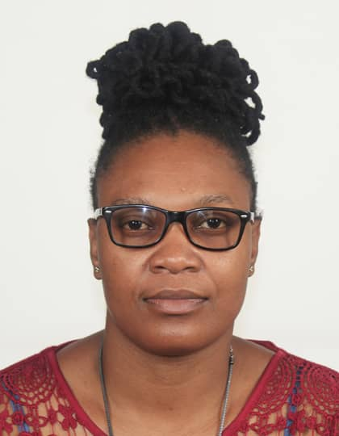
3877 Nketa
Bulawayo, Zimbabwe
Class 4 driver’s licence

__________________________________________________
OBJECTIVES
To utilize my skills while providing high patient quality care.
PROFESSIONAL QUALIFICATIONS
Name of Institution | Qualification | Date Obtained
Alison's Online Academy | Diploma in Caregiving | 2022
Florence Academy | Care work Certificate | 2022

SKILLS
Qualified Vehicle Driver Patience Compassion Communication Committed Team Player Dependable Cleanliness Time conscious
PROFESSIONAL STATEMENT
A diligent, caring, and socially engaged individual. I am a confident and reliable individual offering excellent communication, willingness to adapt and the crucial ability to operate in a fast-paced environment. I am dedicated to making a real difference to the quality of life of elderly people and treating those in my care with care and dignity. Volunteering at care homes and hospitals has been beneficial because I have gained more knowledge under the supervision of experienced colleagues. I particularly enjoy the relationship building aspect of the job, especially forming bonds with clients and their families.
WORK EXPERIENCE
MPILO CENTRAL HOSPITAL BULAWAYO ZIMBABWE
Bed Capacity : 1000
Dates of employment : Jan 2022 - Current
DEPARTMENT: MPILO PRIVATE WARD (MEDICAL/SURGICAL UNIT) 21 BEDDED
Date of Employment : Jan 2022 - Current
Position : Nurse Aide
Nurse patient ratio : 1:5

The ward caters for both male and female patients with medical or surgical diagnosis from the ages of 13 and above. The department supports a broad range of clinical specialities which include:
- Renal failure
- Diabetes Mellitus and Diabetic foot
- Intestinal obstruction
- Upper and lower gastro intestinal bleeding
- Appendicitis
- Open prostatectomy
- Hernia repair
DUTIES AND RESPONSIBILITIES
- Monitoring, recording and reporting any physical, mental or emotional changes in patients
- Providing assistance to patients under care with maintaining personal hygiene, eating,moving ,changing e.t.c
- Ensuring the timely dissemination of accurate information by maintaining thorough patient records and updating healthcare team on patients' status
- Participating in training sessions and worshops to stay abreast with job knowledge
EQUIPMENT HANDLED
- Blood pressure monitor
- Glucometer
- Weighing scale
EKUPHUMULENI GERIATRIC NURSING HOME
Dates of employment : January 2019 – December 2019

- Assisted doctors in providing healthcare and support to elderly patients
- Helped to bathe bedridden patients to prevent bedsores
- administered patients’ prescribed medications in due time
- Helped to conduct regular screenings and routine check-up on patients
- assessed the cognitive skills and mental status of their patients
- Observed, and managed peculiar old age health concerns like incontinence, insomnia, loss of strength and appetite, sexual issues as well as mobility challenges
- Educated the families of their patients on the best ways to care for them and keep them safe
- Maintained a chart for their patients in order to have accurate records of patient’s medical history, treatment plan and progress
- Performed prescribed tests on their patients, like blood

References
Mr. S Sibanda
Nurse in Charge
Ekuphumuleni Geriatric Nursing Home
charles83sibanda@gmail.com
+263712923415
+263 712 923 4125

Mr P. Ncube - "Mpilo Central Hospital "
Hospital Administrator
pncube@mpilo.org.zw
00263773879765

