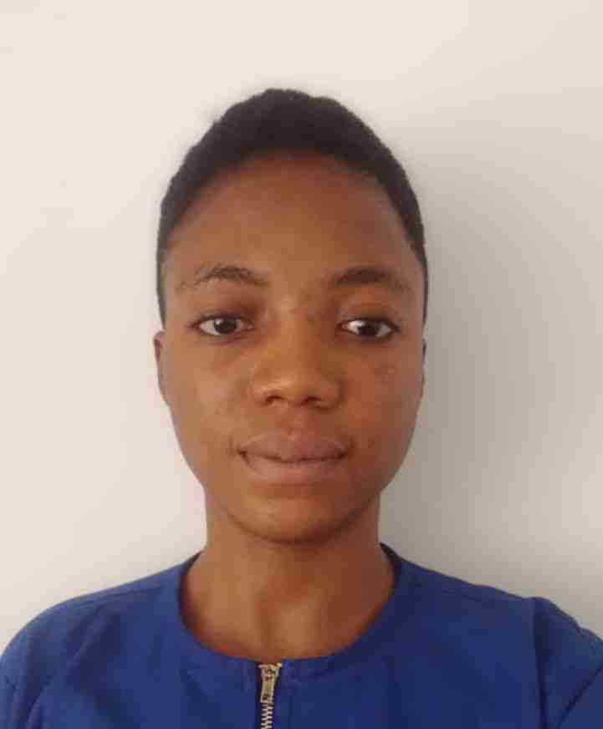
Mary Obasan.
Obasan's House, Odolameso Street,
Ijebu-Imushin, Ogun State,
Nigeria.
+234 7069095930
oreobasan@gmail.com.

Profile.
A caring, compassionate and focused Registered Nurse with 2 years of experience, working directly with patients from neonatal period to geriatrics to meet their daily needs. Notable for displaying the interpersonal skills, communication and team working skills necessary to collaborate with a multi-functional team to deliver high quality care. Have the ability of working well under pressure and ready to learn new skills. Have the passion to assist patients with personal care, physical and mental health needs, while exhibiting the necessary respect and dignity to assist in building their independence. I have ample skills in feeding, pressure area care, mobility, moving and handling, medication administration, risk assessment and IT system. I have been able to achieve high standard of care to patients under my care through safe and individualized care. Ready to offer help through my skills to provide high standard of care and loving atmosphere while also safeguarding adults and children. IELTS score of 7.0 with certificate in diploma nursing (RN), CBT passed according to NMC standard with decision letter to proceed with OSCE.

Work Experience.
Owokoniran Memorial Hospital.
3, Owokoniran street, Sagamu
Ogun State, Nigeria.
60 bed capacity
Staff Nurse: 13th June, 2022 to Current.

Duties and Responsibilities.
Work on rotation basis with a team of 20 nurses. Responsible for assessing, planning, implementing, documenting, evaluating and reviewing about 8-27 patients care plans per shift. Carry out procedures like wound dressing, medications administration, cannulation, ambulation, feeding, toileting, risk assessment, pre and post-operative managements. Also, involve in admission and discharge procedures as well handing over and taking up. Coach junior staffs and manage the unit in the absence of senior nurse. Prioritize workload and accomplish task using personal initiatives. Work in conjunction with a company as their nurse along with a team of 4 nurses on a shift basis upon referral by the hospital.

TGI Group
Sagamu, Ogun State, Nigeria
Company Nurse: 3rd July 2022 to recent.

Duties and Responsibilities.
Work along with a team of 4 nurses. Responsible for caring of about 50patients per day. Carry out procedures like; vital signs monitoring, blood sugar monitoring, malaria test check, wound dressing, oxygen administration and medication administration. Treat patient based on discretion using critical thinking and evidence-based practice and refer patients to hospital promptly when needed for emergency care. Give daily, weekly and monthly report of cases verbally and written making use of IT and mailing it to HR, this in turn helped to monitor the incidence rate of certain health conditions and improvement in healthcare rendered to employees within the company. Take monthly stock of drugs used and brought into the clinic using stock-in, stock-out method.

D'vine Hospital and Maternity Home.
95, Odelemo Road, Sabo, Sagamu
Ogun State, Nigeria
22 bed capacity with an annex of 8 bed capacity
Staff Nurse: 15th February, 2021 to 30th April, 2022.

Duties and Responsibilities.
Worked under the supervision of senior nurses to provide basic support to patients, both in the adult and pediatric unit. Assisted patients with bed bath, mouth care, feeding, mobility, positioning, pressure area care and wound dressing.
Went on regular outreaches with a multifunctional team of care to assess the health status of the elderly.
Provided anti-aging therapies to patients, thus medication administration and other lifestyle modifications.
Attended to women during antenatal, delivery period and postnatal. Also cared for newborn as required giving immunization, bathing and care of umbilical cords and this prevented infection in the babies.
Planned a person centered care plans, updated and reviewed interventions and this brought patients satisfaction in the care given. Educated patients and relatives. Educated patients and relatives (when necessary) of disease condition, prevention and management of same. Gave general talk on Covid-19 to enhance service users to understand and adhere to safety protocols.

Educational Qualification.
National Open University of Nigeria, Abeokuta - Nigeria.
Post Code: 111102
BNSc(in view): September, 2021 to recent.

Ogun State School of Nursing, Idi-Aba, Abeokuta – Nigeria.
Post Code: 111102
Diploma in General Nursing: October, 2017 to November, 2020.

NMC Registration
NMC PRN: 1021972649
CBT: Part A (Passed)
CBT: Part B (Passed)
With decision letter to proceed with OSCE.

English Proficiency Requirement.
IELTS Academic: (Listening - 7.5, Reading - 6.5, Writing – 6.5, Speaking - 7.5) April, 2022.
IELTS Academic: (Listening - 6.5, Reading - 7.0, Writing - 6.5, Speaking - 6.5) July, 2022.

Professional Development
15 Care Certificate Courses- Florence Academy - UK 3rd October 2022 to 9th October 2022

Reference.
Mrs Jacintha Adelakun, Ogun State School of Nursing. dejindidi44@gmail.com, +234 8038274647

Mrs. Ladeinde Abosede, State Hospital. labosede13@gmail.com, +234 8055275898

Dr Babajimi-joseph Igbagbo, Olabisi Onabanjo University Teaching Hospital, +234 8054193982

